

Engineering Mathematics and Physics | Department
------------- | Division
2020-2021 Prepartory | Academic
Computer | Course Name
ECE001 | Course Code
Title:-
ARTIFICIAL INTELLIGENCE

Examiners Committee

Dr.Ahmed Bayoumi | 1
Dr.Shady Elmashad | 2
Dr.Abdelhamid Attaby | 3

BY:-
NAME:- Shorouq Ali Ismail Abd Elalim

GROUP:- (3)

SECTION:- (17)

B.N:- (382)

E-MAIL: Shorouq21203@feng.bu.edu.e
APPLICATION BRIEF:-

In an attempt to clarify the importance of studying the sciences of artificial intelligence, and in an attempt to think about what this science is, this introduction will benefit you, dear reader, God willing.
Only humans are called the mind, because our mental abilities are important in every small and big thing in our lives just as important to us ourselves. The field of artificial intelligence means the mechanization of human intelligence and the study of its mental abilities. One of the most important reasons for studying artificial intelligence is our attempt to understand the operations of the human mind, my mind, your mind and the mind of every generous reader in a way that moves away from philosophy, psychology and anatomy, which in turn is also concerned with the human mind. The science of AI strives to build intelligence as far as it is concerned with understanding that intelligence. The second reason to study this science is that Our smart program is useful in itself and is effective in many areas of our lives that have become digital! Although no one can predict the details of the future, it is clear that the computer with human intelligence will have a huge and clear impact on our daily lives and in the industry of civilization.
Artificial intelligence is an important puzzle: How is it possible for this small brain, whether biological or electronic, to understand, perceive, predict and interact with a world larger and more complex than the brain itself? How can we take the path of making such a small brain with all its complex characteristics? This is a difficult question, but unlike the search for a means of transportation faster than the speed of light, the researcher in the science of artificial intelligence and the student will find that this science is based on solid and possible foundations, all he has to do is look in the mirror to find a living example of the intelligent system.
Artificial intelligence is a modern cognitive science, which officially began in the 1950s. Before this period, we find that a number of other sciences were in one way or another concerned with artificial intelligence and in an indirect way. review of genetics; We find something related to intelligence in the field of studying the genes of scientists in an attempt to attribute their intelligence to heredity. In physics, we find that all students undoubtedly feel that all the good ideas were taken from Galileo, Einstein, Newton and the rest of the scientists, and it is necessary to study for many years so that one of them can make a new discovery! On the other hand, artificial intelligence is still open to occupying a new Einstein with his study all his time.
The search for the nature of intelligence also preoccupied philosophers more than two thousand years ago, as they tried to understand how things are seen, how learning, remembering and reasoning take place. With the advent of computer use in the fifties, these researches turned into realistic experimental systems.

SCREENSHOT
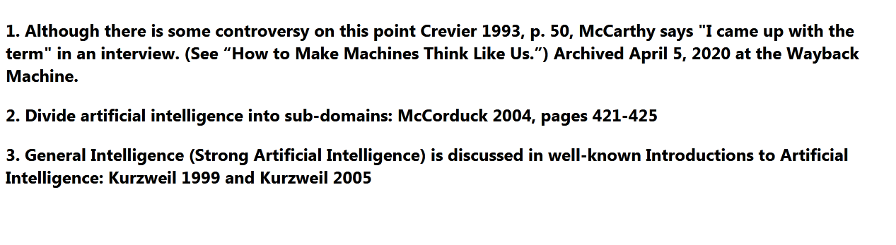
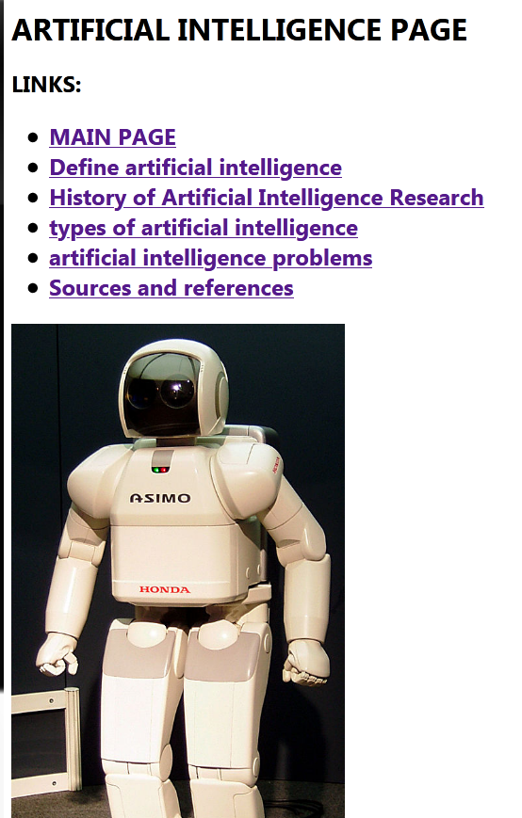
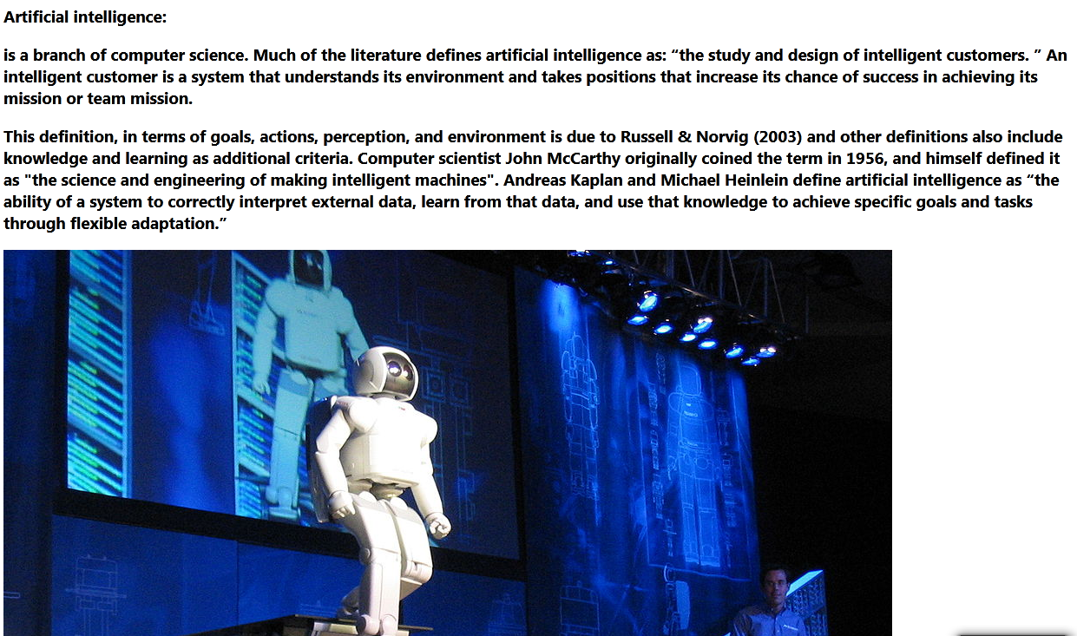

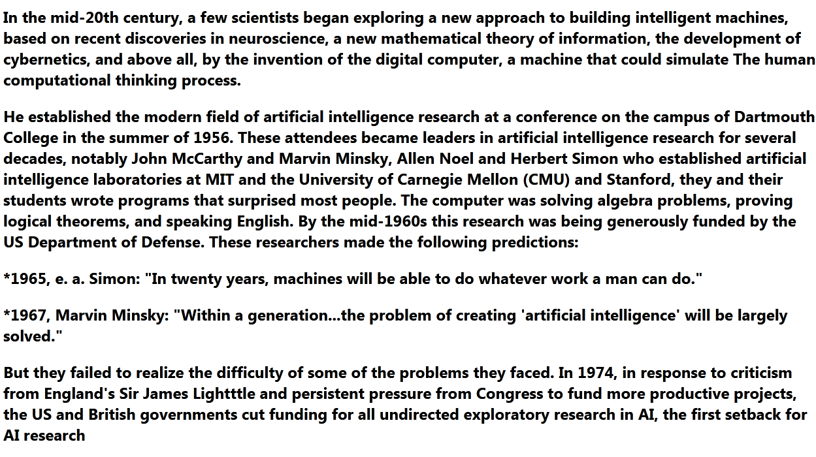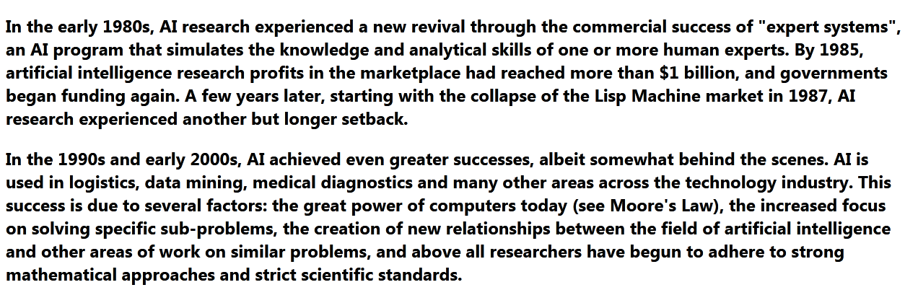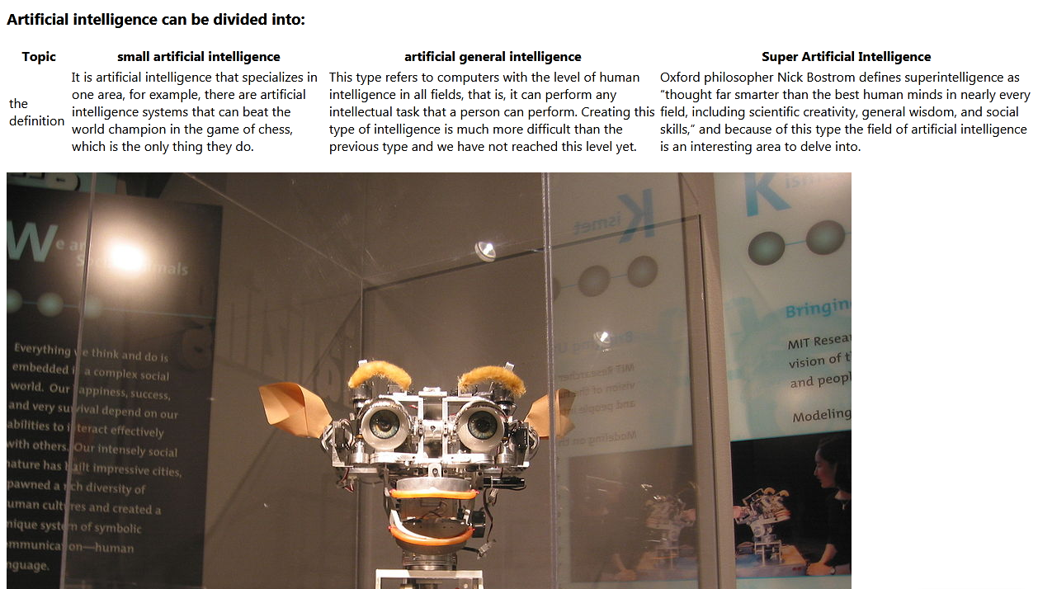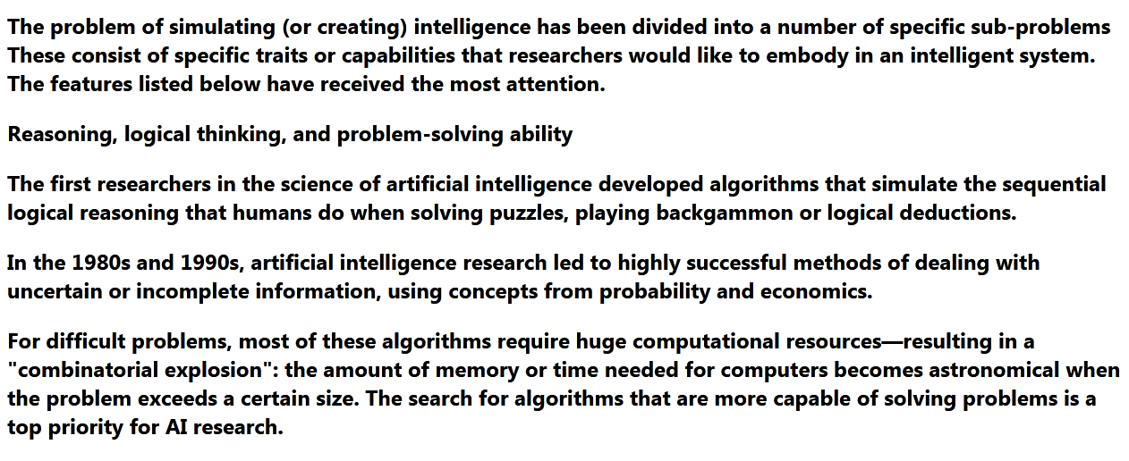

SOURCE CODE
